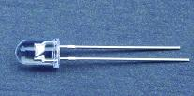
Features
˙High efficiency
˙Low Power consumption
˙General purpose leads
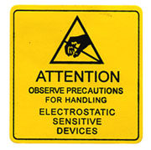
˙Selected minimum intensities
˙Available on tape and reel
˙Pb free

Descriptions
˙The series is specially designed for applications
requiring higher brightness
˙The LED lamps are available with different
colors, intensities, epoxy colors, etc
˙Superior performance in outdoor environment

Usage Notes:
˙The ultra bright LED is an electrostatic insensitive device,so static electricity and surge will damage the LED.It is required to wear a wrist-band when handling the LED. All device, equipment,machinery, desk and ground must be properly grounded
˙When using LED, it must use a protective resistor in series with DC current about 20mA

Applications
˙Status indicators
˙Commercial use
˙Advertising Signs
˙Back lighting

Device Selection Guide

LED Part No. | Chip |  | Lens Color
LED Part No. | Material | Emitted Color | Lens Color
5034SEG3FC | InGaN | Green | Water clear

Package Dimensions
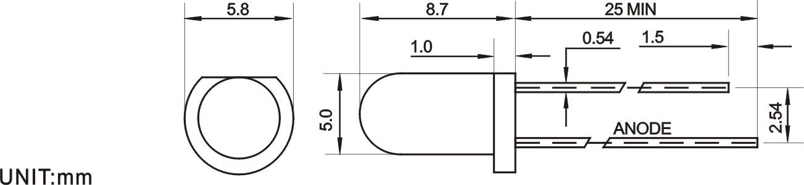
Notes:
˙Other dimensions are in millimeters, tolerance is 0.25mm except being specified.
˙Protruded resin under flange is 1.5mm Max LED.
˙Bare copper alloy is exposed at tie-bar portion after cutting.

Absolute Maximum Rating (Ta=25℃)
Parameter | Symbol | Absolute Maximum Rating | Unit
Forward Pulse Current | I_{FPM} | 70 | mA
Forward Current | I_{FM} | 30 | mA
Reverse Voltage | V_{R} | 5 | V
Power Dissipation | P_{D} | 140 | mW
Operating Temperature | Topr | -40～+80 | ℃
Storage Temperature | Tstg | -40～+100 | ℃
Soldering Heat (5s) | Tsol | 260 | ℃

Electro-Optical Characteristics (Ta=25℃)
Parameter | Symbol | Min. | Typ. | Max. | Unit | Test Condition
Luminous Intensity | Iv | 5000 |  | 7000 | mcd | IF=20mA(Note1)
Viewing Angle | 2θ_{1/2} | 40 | --- | 50 | Deg | (Note 2)
Peak Emission Wavelength | λp | 525 |  | 530 | nm | IF=20mA
Spectral Line Half-Width | △λ | 30 | 35 | 40 | nm | IF=20mA
Forward Voltage | V_{F} | 3.0 | --- | 3.5 | V | IF=20mA
Reverse Current | I_{R} | --- | --- | 10 | µA | VR=5V
Note:
- Luminous intensity is measured with a light sensor and filter combination that approximates the CIE eye-response curve.
- θ_{1/2} is the off-axis angle at which the luminous intensity is half the axial luminous intensity.

Typical Electro-Optical Characteristics Curves

Notes
1. Above specification may be changed without notice. HYLED will reserve authority on
material change for above specification.
2. When using this product, please observe the absolute maximum ratings and the instructions
for using outlined in these specification sheets. HYLED assumes no responsibility for
any damage resulting from use of the product which does not comply with the absolute
maximum ratings and the instructions included in these specification sheets.
3. These specification sheets include materials protected under copyright of HYLED
corporation. Please don’t reproduce or cause anyone to reproduce them without HYLED’s
consent.

